Counting the Invoices

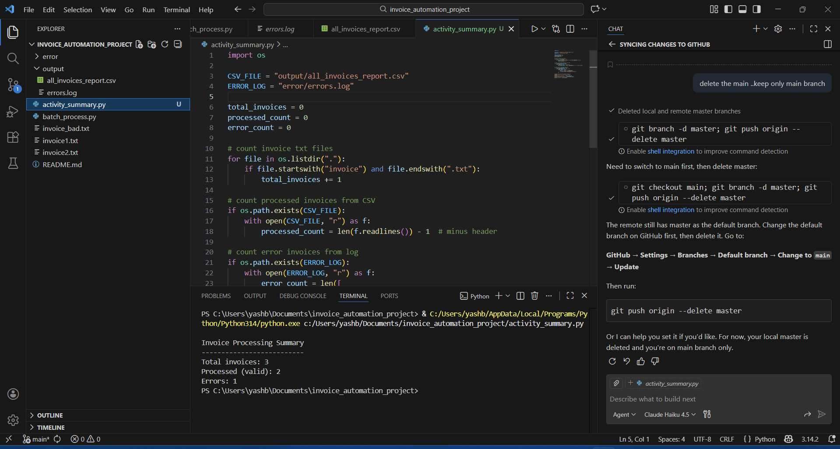
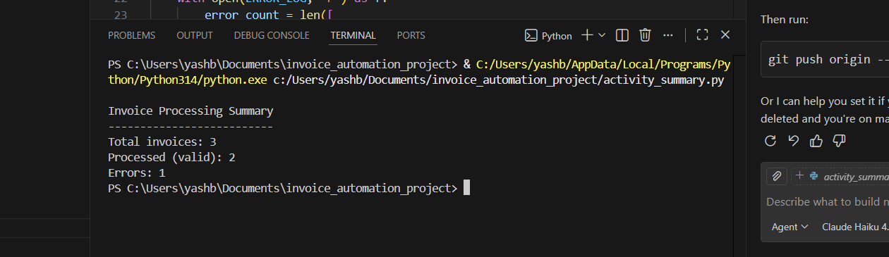
Highlight INVALID invoices clearly
What this activity does
It will:
- Read errors.log
- Print which invoices failed
- Print why they failed
STEP 1: Create a new file
Create a new Python file- activity_show_errors.py
Step 2: Paste this code in activity_show_errors.py
if not os.path.exists("errors.log"):
print("No errors.log file found")
else:
print("Invalid Invoices and Reasons")
print("----------------------------")

with open("errors.log", "r") as f:
for line in f:
if line.strip():
print(line.strip())

Step 3: Run this command in Terminal.........python activity_show_errors.py

